Event
Booklet

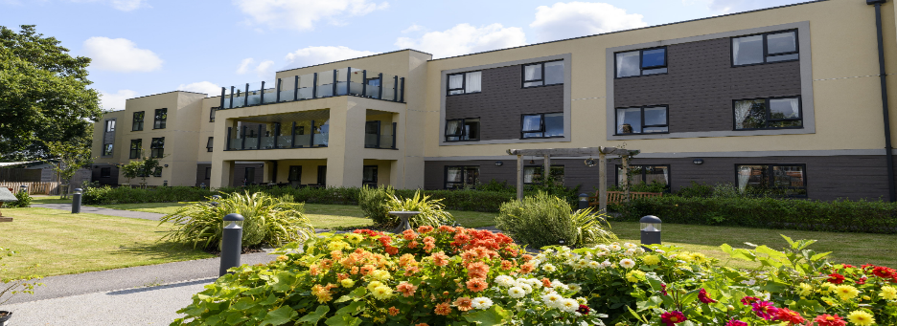
Speedwell Court
Residential & Dementia Care Home Home

See enclosed for event information supporting
our local community
Dementia &
Carer Advice
& Support

Lead by Andover Mind

Day Care - Full or half days
Dementia Friends Session

Learn how to become a dementia friend & help the community

Community Sessions aimed at those living with dementia and their carers:

- Lunch Club
- Hairdressing Services
- Cinema Club

Please see inside for more details or pop in and look around
Address: Mansbridge Road, Southampton SO18 3HW
T: 02382356990 / E: speedwell@abbeyfield.com


‘FREE’ Dementia Friends Session
Speedwell Court, Mansbridge Rd, West End, Southampton SO18 3HW
Held monthly
What is a Dementia Friend?
A dementia friend is somebody who learns about dementia so they can help their community from a professional or personal perspective.
By raising awareness & understanding we can support people living with dementia so that they continue to receive the respect & support they deserve.
A pin is given for each person completing the training.
To book a place please contact Justine Owen on 02382 356990 or email j.owen@abbeyfield.com
(Spaces are limited so please call to book your space)

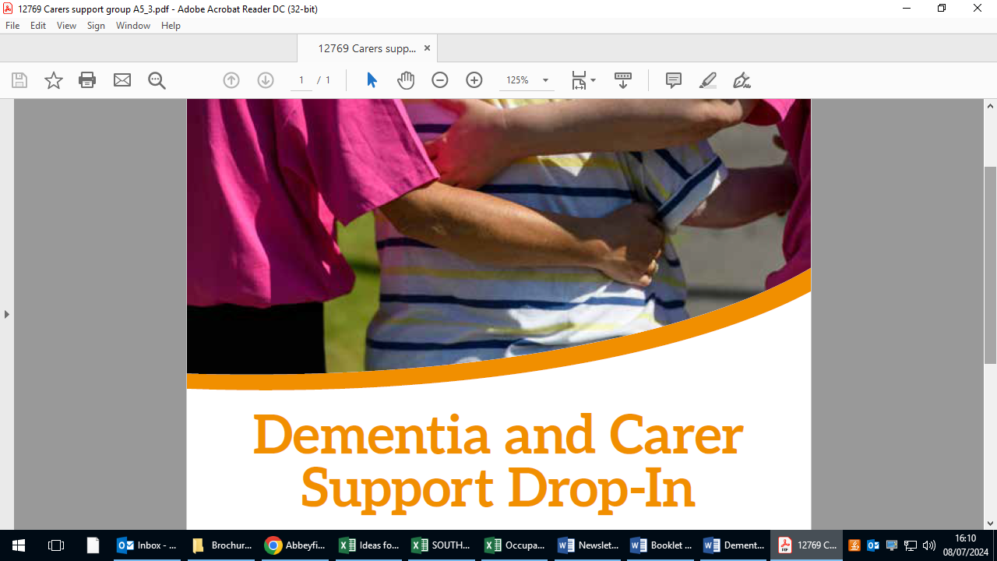
A dementia friendly drop-in for carers of people with dementia. Join us for coffee & biscuits & receive advice & support.
1st Wednesday of every month, from 2pm until 3:30pm
To book contact speedwell@abbeyfield.com or call 02382 356990
Speedwell Court, Mansbridge Road, Southampton, SO18 3HW

DAY CARE
Feel like you are home

Speedwell Court, Mansbridge Road, Southampton, SO18 3HW

Full or half days on Mondays – Friday

Do you need some respite from being a carer?

Our full days are 9-5 including meals at just £85

Half days at £50

For more information please call us on: 02382 356990
or email: speedwell@abbeyfield.com

Speedwell Court
Community Lunch Club

We facilitate a lunch once a month.
A dining experience in which to meet new friends in the same situation, enjoy a change of scene and have something nice to eat.

This free event is aimed at those with dementia & their carers, who would benefit from some company without the concern of another expense.
.

Spaces are limited so please book in advance
02382 356990 or speedwell@abbeyfield.com

Speedwell Court, Mansbridge Road, West End, Southampton SO18 3HW (opposite Haskins)

Dementia Friendly
Hair Care
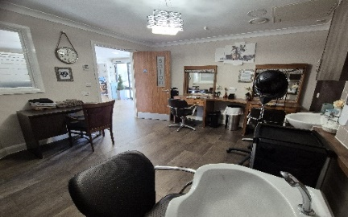
Always Glamorous Hair & Beauty
Support the community to enjoy hair care services, including barbering.
With many years experience in providing person centred, dementia friendly treatments, we manage our clients with patience and dignity.
Sessions are on the first Wednesday of each month between 13:30 – 15:30 Appointment required
Carers are welcome to sit & enjoy a coffee in the café while they wait
For more information, please call: 02382356990
Located at Speedwell Court Care Centre, West End, Southampton SO18 3HW

We would like to invite you to:

Speedwell Court’s
Community Cinema Club


Running the First & Third Friday of each month 2:30 – 4:30
Aimed at those living with dementia, and their carers, within our local community.
Come along to our community cinema club & feel comfortable, safe & welcomed in our understanding & caring environment. There is no pressure to have to stay to the end.
- Classic films from the 50’s, 60’s & 70’s (suggestions welcome).

- Singalongs, upbeat & timeless movies to evoke good times & good memories.

- Refreshments provided.
Call 02382 356990 or email speedwellcourt@abbeyfield.com to find out more

